CMC2026 Abstract templae - Title should be bold; font 15, Times New Roman; line spacing 1.0
Surname Nameª, Smith Jane^{b} and Smith John^{b}
ªEnter full name of the first institution with address included
^{b}Enter full name of the second institution with address included
Corresponding author: email@domain.com

Abstract should be written with maximum of 3000 characters (including spaces), do not exceed one page (excluding figure page); font 11, Times New Roman; line spacing 1.0; justified. The abstract should briefly include the background, methods, results and conclusion (no need to separate each section). You can add maximum of 3 references in the abstract and maximum of 1 figure on next page. Each reference must be on a separate line with the format represented bellow. This section may also be used for acknowledgements, if needed.

1. X.Y. Name et al., Journal Name 5 (2015) 25–250.
2. X.Y. Name et al., Journal Name 5 (2015) 25–250.

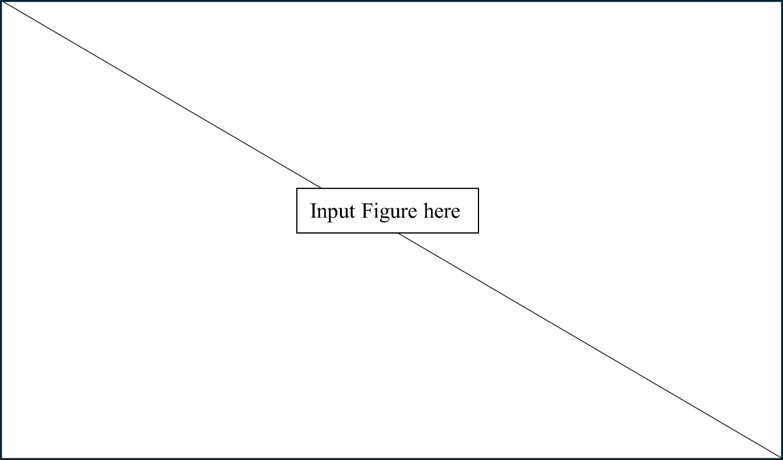
Figure 1. Description of Figure 1. Figures should be clear and readable.

